Name:Mohammed misbahuldin k(1965260109)
EXPERIMENT-8
DATA LINK LAYER TRAFFIC SIMULATION USING PACKET TRACER ANALYSIS OF ARP

Aim: To implement Data Link Layer Traffic Simulation using Packet Tracer Analysis of ARP.
Software / Apparatus required: Packet Tracer / End devices, Switches, connectors. Requirements:
1. End device - They are the devices through which we can pass message from one device to another and they are interconnected.
2 Switch/Hub - Interface Between two devices.
3. Cable - Used to connect two devices Procedure:
- Open packet tracer.
- Click on the list the available capture interface.
- Choose the PCS, server and Hub.
- Later give connection from hub to the remaining pcs.
- Give IP address to the pcs with configuration.
- Simulate the source and destination.

Diagram
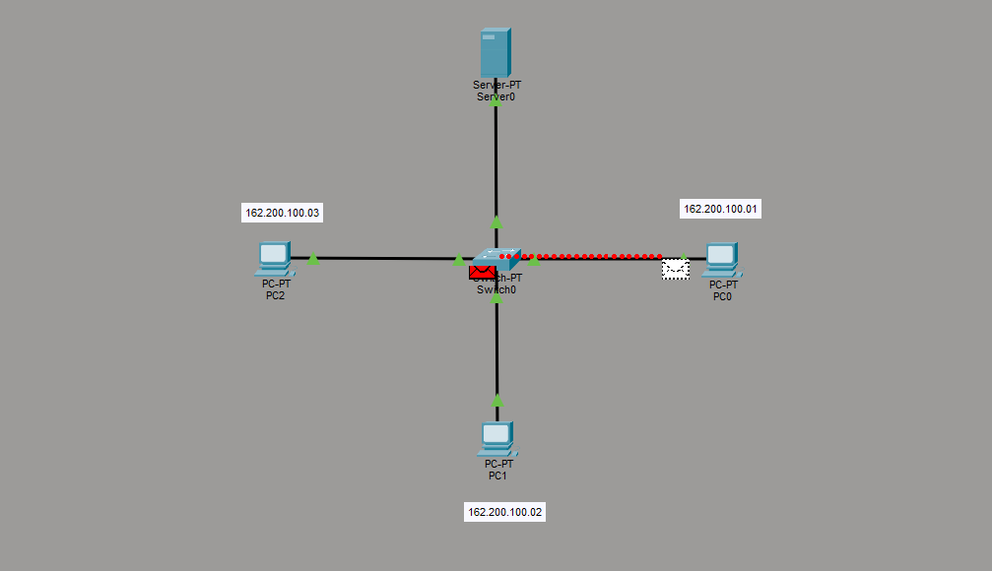

Output :
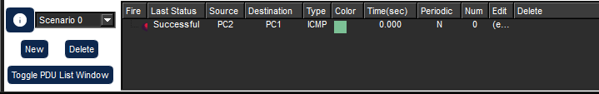

Result: Thus theData Link Layer Traffic Simulation using Packet Tracer Analysis of ARP is implemented.
Date:
EXPERIMENT-9
DATA LINK LAYER TRAFFIC SIMULATION USING PACKET TRACER
ANALYSIS OF CSMA/CD & CSMA/CA

Aim: To implement Data Link Layer Traffic Simulation using Packet Tracer Analysis of CSMA/CD & CSMA/CA.
Software / Apparatus required: Packet Tracer / End devices, Switches, connectors. Requirements:
1. End device - They are the devices through which we can pass message from one device to another and they are interconnected.
2 Switch/Hub - Interface Between two devices.
3. Cable - Used to connect two devices Procedure:
STEP 1: Click on end devices, select generic Pc’s drag and drop it on the window. Click on SWITCH drag and drop it on the window.
STEP 2: Select the straight through cable and connect all end device to switch. Assign the IP address for all end devices. (Double click the end device Select → desktop → IP configuration static)
STEP 3: Now set the IP address to Host A (192.168.1.1) in static mode. Similarly set IP address for Host B (192.168.1.2) and Host C (192.168.1.3)
STEP 4: To view the IP address, give ip config command in command prompt. Using ping command, we can establish communication between two host devices.
STEP 5: Now display the packet transmission in simulation mode.

Diagram:
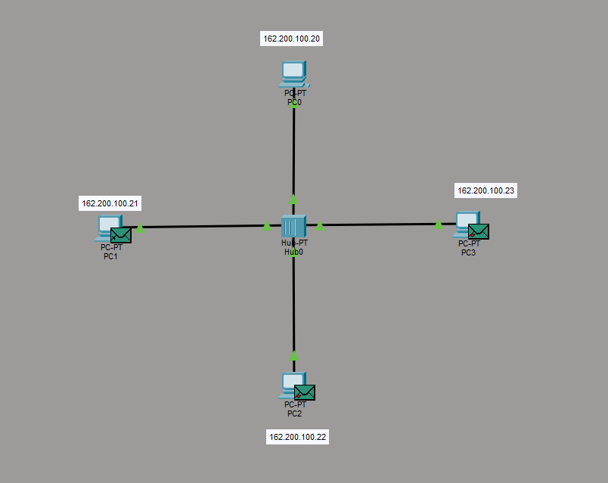

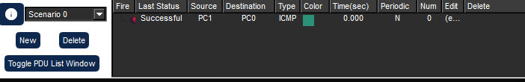
Output:

Result: ThusData Link Layer Traffic Simulation using Packet Tracer Analysis of CSMA/CD & CSMA/CA is implemented successfully.
Date:
EXPERIMENT-10
MAKING COMPUTER LAB IN CISCO PACKET TRACER
Aim: Making Computer Lab in Cisco Packet Tracer.
Software / Apparatus required: Packet Tracer / End devices, Switches, connectors.
Procedure:
Step 1: Launch Cisco Packet Tracer and create a new project.
Step 2: Select the appropriate network devices for your lab. In this case, you will need computers, switches, and routers. You can find these devices in the "End Devices," "Switches," and "Routers" sections of the device list.
Step 3: Drag and drop a switch onto the workspace area. Connect the switch to the power source by clicking on the "Connection" option and selecting "Power."
Step 4: Connect computers to the switch by dragging and dropping them onto the workspace area. Click on the "Connection" option and select "Fast Ethernet" to connect the computers to the switch.
Step 5: Repeat Step 4 to add more computers to the lab. You can adjust the number of computers as per your requirements.
Step 6: Connect the switch to a router. Drag and drop a router onto the workspace area and connect it to the switch using a serial cable. To do this, click on the "Connection" option, select "Serial," and then select the appropriate serial interface on the router.
Step 7: Configure IP addresses on the computers. Select a computer, click on the "Desktop" tab in the device configuration panel, and configure the IP address, subnet mask, and default gateway for each computer.
Step 8: Configure IP addresses on the router interfaces. Select the router, click on the "CLI" tab in the device configuration panel, and enter the interface configuration mode. Assign IP addresses to the router interfaces connected to the switch and computers.
Step 9: Test connectivity. Open the command prompt on each computer and try to ping other computers and the router's interfaces to ensure connectivity.
Step 10: Customize and expand the lab as desired. You can add additional devices, configure VLANs, implement security measures, or set up servers within the lab environment.

Diagram:
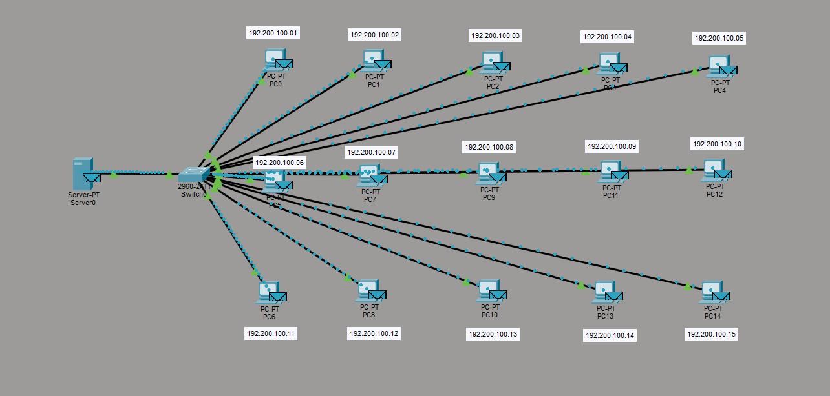

Output:

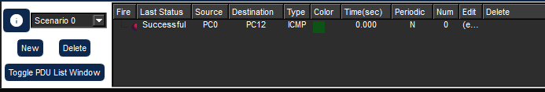

Result: Thus the Computer Lab in Cisco Packet Tracer is set up successfully.

